Software Engineering

Project Deliverable (Draft)

# JustAMeet

Brinden Robinson

Harsh Pathak

Jacob Pitoniak

Javier Gomez

Kermit Alexander

Sanjay Poudel

Rishi Dandu

**1.**

**Final project draft description**

To rejuvenate the world of online dating,considering online dating is trending at an all time high and continues to rise. However, what if your first choice isn’t your best choice? We want to help people find their true soulmate based on their personalities and interests, not just by a 5 second glance at their “looks” which can often be deceiving. We want our software to facilitate a more meaningful connection between users instead of a shallow hook-up.

**Feedback Response**

Online dating software such as Tinder and Bumble shifts the user focus to swipe based solely on looks since the user decides to like or dislike based on the other person’s pictures. With this project we are focusing on making users match using other factors not just pictures. Our project consists on making users establish a link via interests initially. The link between interests we are trying to generate it by making users swipe on events or venues first and then give a list of users who are also interested in that event. By clicking on venues such as museums and restaurant, or events such as concerts and sports events first, an initial interest is shared and we believe that this would allow for a meaningful connection between users. A considerable contrast between Blind Event and other dating software is that we are limiting the number of likes towards other users so each match is considered valuable and special. An additional feature we would implement is a match probability which we generate by making users take an initial survey at the time of registration, their responses are stored and introduced to our algorithm which determines a probability based on the similarity with the other user.

**2. Delegation of tasks**

Brinden Robinson

* Sequence Diagram
* Mobile UI Design

Harsh Pathak

* Mobile UI Sourcer/Design

Jacob Pitoniak

* Requirements
* Documentation of project (project deliverable)

Javier Gomez

* Requirements
* Documentation of project (project deliverable)

Kermit Alexander

* Class Diagram

Sanjay Poudel

* Architecture design

Rishi Dandu

* Use Case Diagrams

**3. Software process**

The software process employed in the project is the plan-driven approach. The project is being broken into separate phases within a predetermined time frame. Clearly we are spending considerable time in the Requirement and Design phase. Evidence of a Plan-Driven approach is the documentation around the application such as a requirements document, class diagram, sequence diagram , and use case diagram. By following this software process each individual is in charge of a task and each member has a specified delivery date for their task list. Task monitoring using a plan-driven approach is also evident in our project considering that every member knows exactly what the other member is in charge of.

**4. Software process model**

The software process model employed in the project is the waterfall method since we are following a sequential process in terms of development. To support the usage of the waterfall method we have established a predetermined set of functional and non-functional requirements. Since the Requirements are well understood it is inflexible to go back to change the main focus.

The stages of waterfall are Requirements, System and software design, implementation, and finally operation and maintenance. For this project we are mainly focusing on the first two stages. By providing enough documentation supporting the Requirements and Design developers would have a better understanding as to what is necessary against desirable and take opportunity costs into consideration without the involvement of the customer, which is characteristic of a waterfall method implementation.

**5. SOFTWARE REQUIREMENTS**

**5.A) Functional**

User must provide name age gender and email at the time of registration which should be secured in a database.

User must fill the ten questions in the initial survey to continue using the application

User must select a city to browse events, after the user has selected a city the category of events provided for that city should be displayed.

User must be able to choose event category and actual event within the category .

The algorithm will provide a rating based on the initial survey response to serve as a suggestion as to which match might be more similar to each other

User must to be able to view profile of the top 6 matches based on the rating algorithm and select only 3 per day

User must have the option of deleting his or her account which deletes the users data from the database.

User must provide correct and matching login credentials at login phase if application is deleted or user logged out.

1. **Product Requirements**
   1. **Usability**
      1. Registration page must be displayed within 3 seconds of initially starting the application, this should include name age gender email and creation of password.
      2. System should display Event category list including Sports,Concerts,Museums, Restaurants , Theater, Bars that are currently open so it should be updated every hour .
      3. User must be provided with an interface with the top 6

percentage matches within 10 seconds, if no matches for the place or event are available, message should be displayed saying “No users have chosen this Event”

* 1. **Efficiency**
     1. **Performance**

Software must provide an initial response survey within 2 seconds of registration with questions and drop down multiple choice answers, that data from the survey should be transferred to the database once all questions are answered instantly.

* + 1. **Space**

Once a category event has been chosen, system must display list of available events in chosen category and city within 2 seconds of clicking the category event.

* 1. **Dependability**
     1. Top 6 percentage matches must be renewed daily, and has to be able to manage the scenario of new people attending the event.
  2. **Security**
     1. Initial response survey and registration data has to be kept in a secure environment

1. **Organizational Requirements**
   1. **Environmental**
      1. Developers in the project should all be using the same IDE
   2. **Operational**
      1. The system that should be an application that supports Heterogeneity across Android and ios.
   3. **Development**
      1. The Software should be developed using Java following an object-oriented programming model

**3. External Requirements**

* 1. **Regulatory**
     1. The application should only allow people over the age of 18
  2. **Ethical**
     1. User data should not be published to any third parties
  3. **Legislative**
     1. **Accounting**
        1. must disclose to the user that we receive a kickback for providing a coupon code for tickets
     2. **Safety/Security**
        1. Follow federal laws/mandates about storing personal user information

**5.C) Domain Requirements**

Must run smoothly and be secure on both Android and IOS devices

**6. Use case diagram**

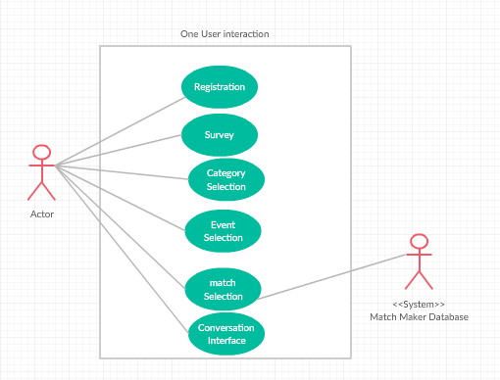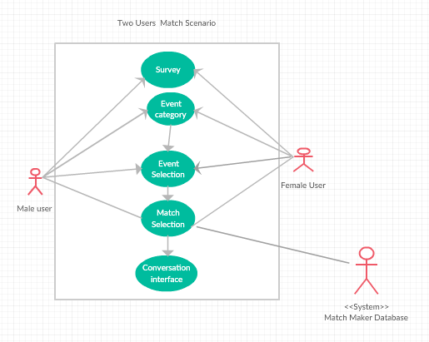

**7. Sequence diagram(s)**

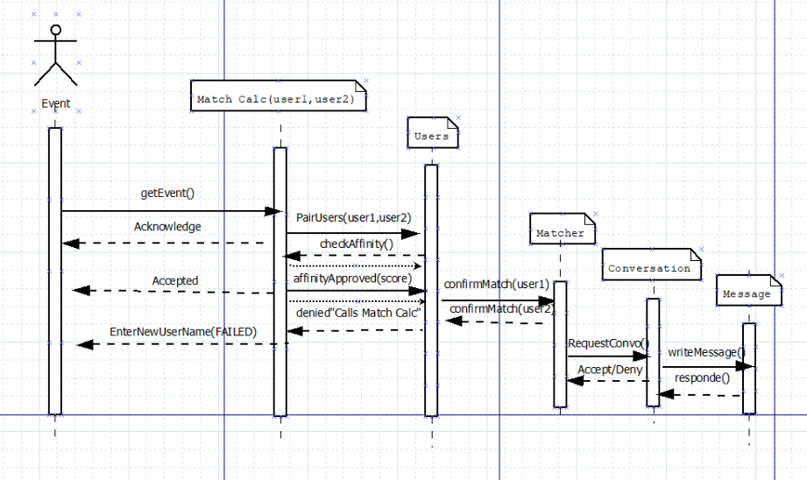

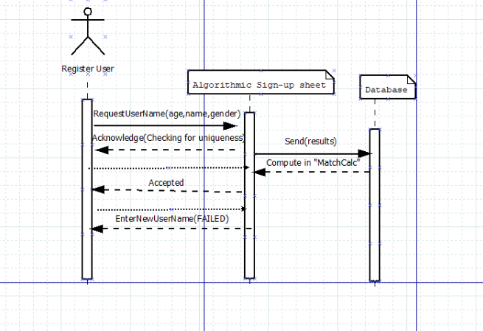

**8. Class Diagram**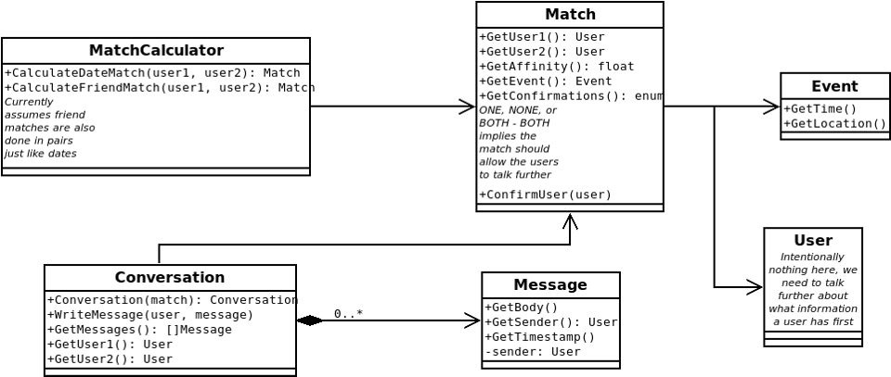

**9. Architectural design**

